TASK D1
IMPLEMENT SECURITY CONTROLS
USER ROLE | PERMISSION | REASON
Administrator | SELECT, INSERT, UPDATE, DELETE | Mainly needs full access to manage the database
Receptionist | SELECT, INSERT, UPDATE, DELETE | Need to be able to accent patient’s information and able to book appointments
Patient | SELECT | Access limited to approved patient data
Doctor | SELECT, INSERT, UPDATE | Needs to access information about patient’s diagnosis or prescriptions also update if needed

Figure 1 4 roles within database

Appendix
Receptionist
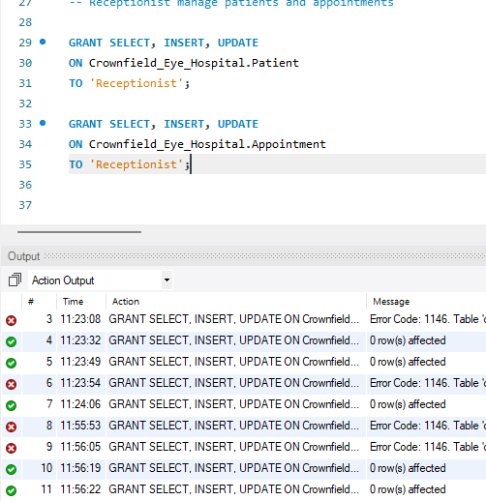

Administrator
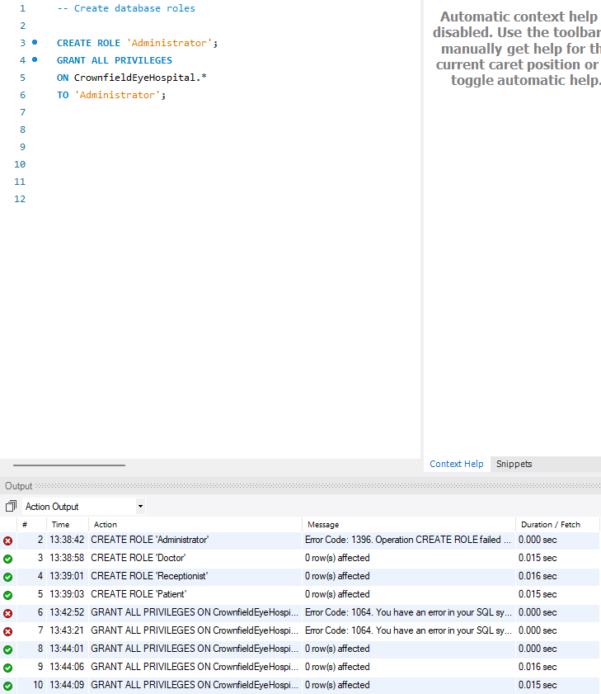

Doctor access
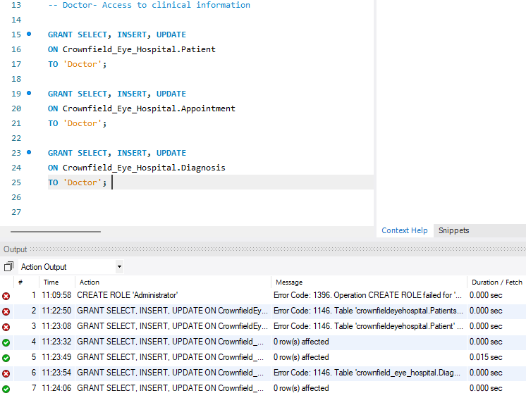

Patient access
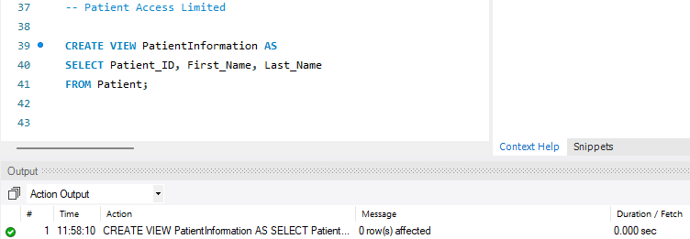

Task D2- Protective sensitive patient information
I’m going to display how the hospital can protect private patient information.
- Created a table for encrypted information
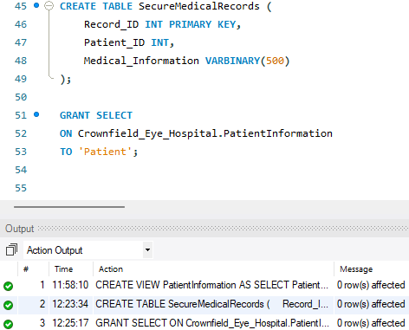

- Encrypting the patient’s information

- Viewing the Encrypted information
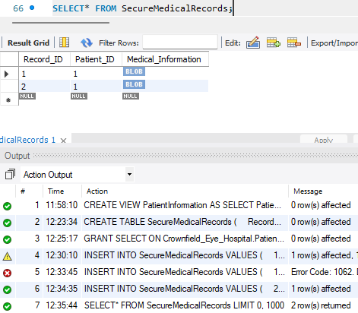

- Decrypt the information
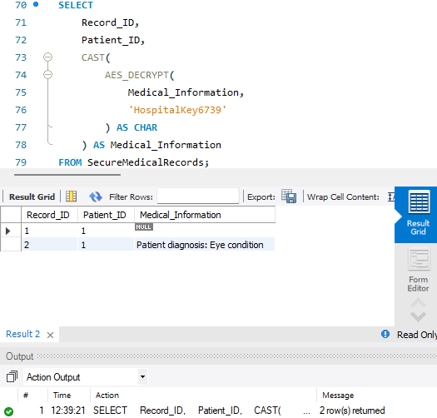

Explanation
Security controls were implemented to protect sensitive patient information safe in the Crownfield eye hospital database. Four database roles were created: Administrator, Doctor, Receptionist and Patient. Each role was assigned different permissions depending on its responsibilities. The Administrator was given full database access, while Doctors were permitted to view and update clinical information, including diagnoses and prescriptions. Receptionists were given access to patient details and appointment records to support administrative tasks. Patients were given restricted access to view authorised personal information. Data protection techniques were also considered to improve the security of confidential hospital records. AES encryption was also demonstrated to protect sensitive medical information by converting readable data into encrypted values. In addition, SQL injection was considered as a potential security threat. Parameterised queries help prevent attackers from manipulating SQL statements through user input. Overall, these security measures help protect patient confidentiality, reduce unauthorised access and maintain the integrity of the hospital database.

